

**DOCUMENTAION**

**OF**

**E-PROJECT:**

Group Members:

|  |  |
| --- | --- |
|  |  |

|  |  |
| --- | --- |
| ENROLLEMENT NO: | STUDENT NAME: |
| Student918968 | KHURRAM AKRAM |
| Student 918853 | MUHAMMAD YOUNIS |



**Acknowledgement**

The successful completion of this project is indebted to the Grace of the ALLAH Almighty, who has always kind to us.

We are also highly obliged for the valuable guidance of our Respected Teacher **Sir Mazhar** for imparting knowledge and boosting moral towards enhancement of confidence, during the preparation of Project.

We also recognize the special contribution by course mates for their valuable guidance and expert knowledge in compliance of this report.

***GROUP MEMBERS***

**Khurram Akram**

**Muhammad Younis**

**STUDENTS OF APTECH**

**COMPUTER EDUCATION.**

Certificate of Completion

**This is to certify that Website for KSC Technology and Sciences Website Using For ASP.NET MVC**

**Has been completed with all functionality by the students of**

**IPRO-201509B1.**

**NAMES: KHURRAM AKRAM**

**MUHAMMAD YOUNIS**

DATE: 18-JULY-2018

Introduction:

The thirst for learning, upgrading technical skills and applying the concepts in real life environment at a fast pace is what the industry demands from IT professionals today. However busy work schedules, far-flung locations, and unavailability of convenient time-slots pose as major barriers when it comes to applying the concepts into realism. And hence the need to look out for alternative means of implementation in the form of laddered approach. ­

The above truly pose as constraints especially for our students too! With their busy schedules, it is indeed difficult for our students to keep up with the genuine and constant need for integrated application which can be seen live especially so in the field of IT education where technology can change on the spur of a moment. *Well, technology does come to our rescue at such times!!*

Keeping the above in mind and in tune with our constant endeavour to use Technology in our training model, we at Aptech have thought of revolutionizing the way our students learn and implement the concepts using tools themselves by providing a *live and synchronous eProject learning environment!*

**So what is this eProject?**

eProject is a step by step learning environment that closely simulates the classroom and Lab based learning environment into actual implementation. It is a project implementation at your fingertips!! An electronic, live juncture on the machine that allows you to

* Practice step by step i.e. laddered approach.
* Build a larger more robust application.
* Usage of certain utilities in applications designed by user.
* Single program to unified code leading to a complete application.
* Learn implementation of concepts in a phased manner.
* Enhance skills and add value.
* Work on real life projects.
* Give a real life scenario and help to create applications more complicated and useful.
* Mentoring through email support.

**How do we start accessing the Sample eProject?**

The students at the centre are expected to complete this eProject and send complete documentation with source code within the time allotted to eprojects@aptechfze.ae

Looking forward to a positive response from your end!!

**Problem Statement**

**Introduction**

KSC Technology and Sciences is the educational university which runs the classes for the categories like Engineering, Pharmaceutical sciences, Literature, etc. It is one of the famous universities in the country. They generally conduct Paper Presentations at state level and national level. They also conduct seminars, Techno-Feat, etc. so as to entertain the students in the technical back grounds.

Each time when they conduct seminars, symposiums, or paper presentation, etc. they used to send the invitations for the participation of the students of other colleges, etc. so that the knowledge of the student can be enhanced and at the same time, the students who does not belong to this university can also have the opportunity in participating in these activities.

While sending the invitations to the other colleges, universities, they quote some registration fees for the gate pass and also they will provide the details like the topics for which seminars or paper presentations or symposiums or techno-feats are conducted. For the seminars and the Techno-feats they also provide the names of the speakers who are conducting or providing this. Along with the invitation they also send the format of application, which is to be filled and sent back to the address as mentioned in the invitation for participating in the activities.

In general to participate in these activities, the students who do not belong to this university send their requests by filling in the application form as per the format sent and send it along with the payment through courier or directly dropping it at the address in personal. In case of the Paper presentations, along with the courier, they also used to submit both the soft copy and the hard copy, so that they can reach the mentioned address before the end date of the participation. After sending these copies, they used to verify and then finalize which students are to be participated in this paper presentation. The selection is purely based on the technology (like mostly they prefer the new implementations in the technology, etc.).

**Customer Requirement Specification**

Now they want to provide a facility where the participants can register themselves online and as well the invitation can be displayed directly online itself in the specific portal. Once they are registered online they can send the details of the payment along with the print out of the application along with the signature of the participant and for the paper presentation, the hard copy of the paper presentation will be sent along with it. So they have approached us in order to help them.

They want that the following steps to be incorporated in the website.

1. There should be a logo indicating the brand of the institute on all the web pages. (Note: the logo can be of any institution or it can be designed by your own as well)
2. On the home page of the website the details of the upcoming activities, and the winners of the recent activity conducted is to be displayed. Also the details of the

winners of the recent activity conducted is to be displayed. Also the details of the participants like how many are registered for the recent or for the latest activity conducted can be displayed on the home page.

1. The user can also create the account with the website, with his/her personal mail id. So that if any activity is going to be launched a mail will be marked to the mail id that is mentioned during the time of registration with the site.
2. When a user tries to access the link of the activity like symposium, seminar, techno-feat, etc. he/she should be able to view the details like
   * Date and time of conducting
   * The procedure for applying for the participation
   * The fees details
   * Payment options
   * Eligibility criteria
   * Speakers name or guest’s name
   * Topics on which the activity is performed
   * Prize details if any
   * Address for sending the applications for the participation
   * Terms and conditions, etc.
3. The navigation bar should include the following

* Home Page
* Login Page
* Application or enroll Page
* Update/Edit Page
* Subscribe Page (through this one can create the account) and unsubscribe
* Page (through this one can deactivate the account created)
* About Us Page
* Contact Information Page

1. Through Login page, users and admin can login.
2. Through the Enroll page one can enroll or apply for symposiums, seminars, Techno-Feat, etc.
3. Through Un-Enroll for an event (symposiums/seminars/Techno-Feat)
4. Through Subscribe Page one can subscribe for the mailing lists and create the account with the site.
5. Through Unsubscribe Page one can subscribe for the mailing lists.
6. Through Update page that is available after login one can Manage Personal Information
7. It should also include the About Us and Contact information.
8. The payment options to be included are

* Payment through Demand Draft
* Payment through Cheque
* Payment by cash

1. The application can be done in both the ways

* Online application

Note: The payment can be sent through the courier or dropped at the address. Once the payment is cleared, then only the enrollment will be activated.

* Taking the print out of the application and filling it up and sending it through courier to the address mentioned.

# HARDWARE AND SOFTWARE:

**Hardware :**

* A minimum computer system that will help you access all the tools in the courses is a Pentium 166 or better
* 64 Megabytes of RAM or better

**Software :**

* VISUAL STUDIO
* SQL Server Management Studio 2008/12/13

#### Task Sheet:

|  |  |
| --- | --- |
| STUDENT NAME : | TASK: |
| KHURRAM AKRAM | Coding/designing/Developing |
| MUHAMMAD YOUNIS | Coding/designing |

**ER DAIGRAM**

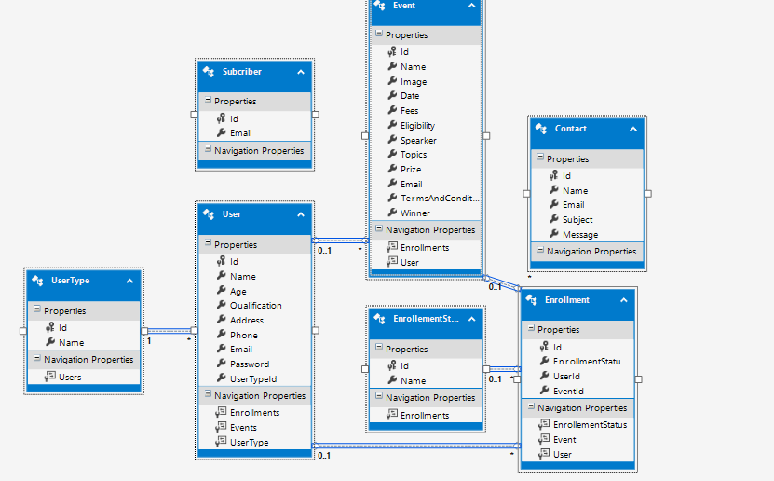

**KSE SCIENCE AND TECHNOLAGY**

**Login Page**

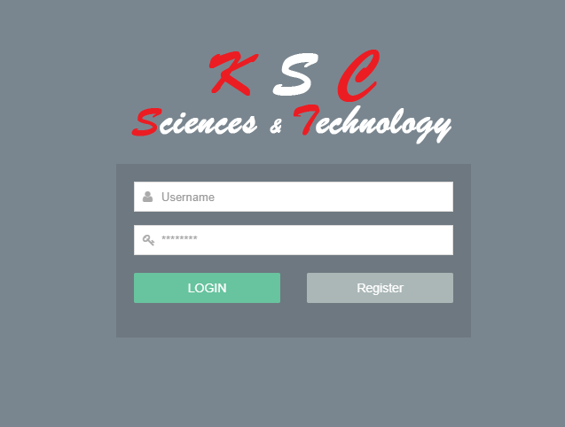

**Registration Form:**

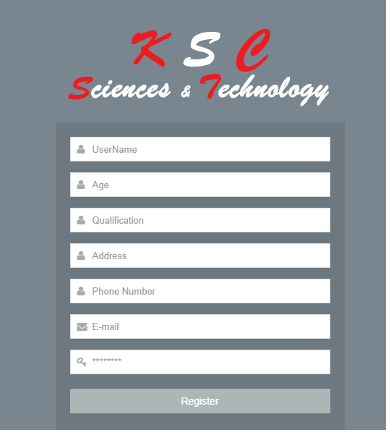

**Event Page**

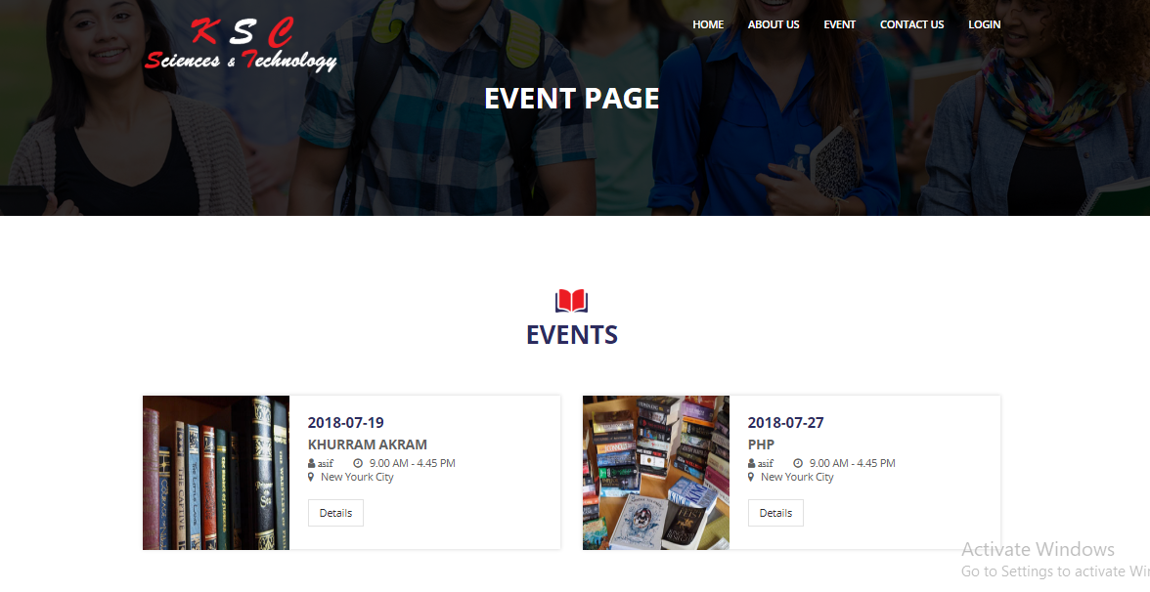

**Abouts us**

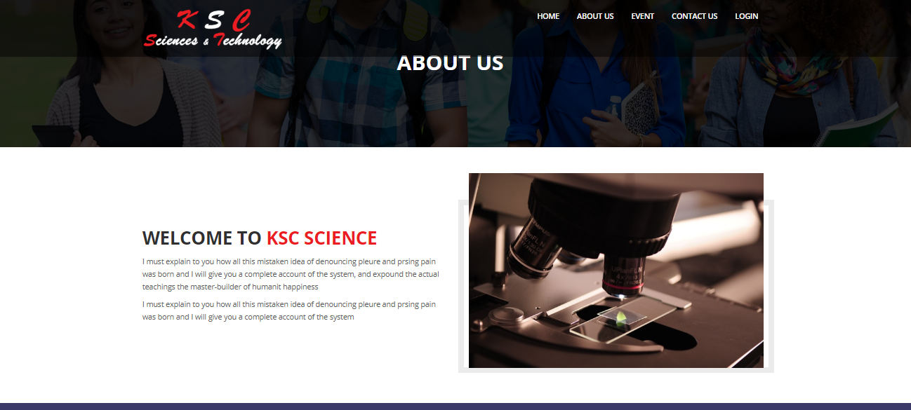

**Contact us:**

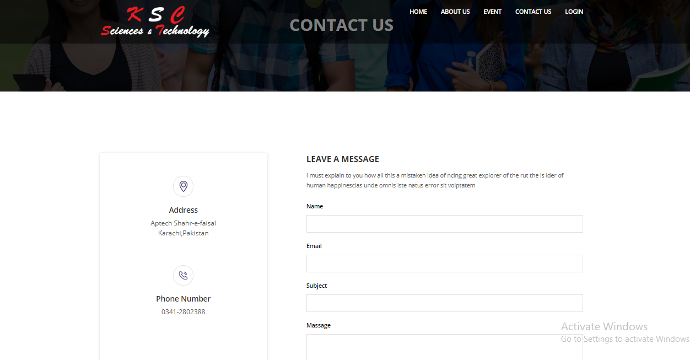

**Home Page**

